***+ANUDIP FOUNDATION***

A Project Report on

**LIBRARY MANAGEMENT SYSTEM**

By

Batch: ANP-D0453

Student ID: AF0477136

Name: Archana Pagul

**Under the Guidance of**

Mrs. Rajshri Chandrabhan Thete

LIBRARY MANAGEMENT SYSTEM

Introducing our Java-based Library Management System (LMS):

A Library Management System (LMS) is a software application designed to manage and organize library resources efficiently. It helps in maintaining records of books, staff, readers, and transactions such as book issues, returns, and reservations. The Entity-Relationship (ER) diagram above represents the structure of an LMS, illustrating key entities such as Books, Readers, Staff, Publishers, Authentication System, and Reports, along with their attributes and relationships.

In this system, Readers can borrow or reserve books, while Staff manages book records and monitors transactions. The Authentication System ensures secure access for users. Additionally, Publishers are linked to books, and Reports help in tracking library operations. The diagram provides a clear visualization of the database structure, helping in the efficient design and implementation of the system.

**Entities:**

* Admin
* Staff
* Reports
* Readers
* books
* Publisher

**ATTRIBUTES OF ENTITIES:**

1. **Admin**

* Attributes:
* Login_id (primary key)
* Password

1. **Staff**

* Attributes:
* staff_id (primary key)
* staff_name

1. **Reports**

* Attributes:
* Reg_no(primary key)
* User_id(Foreign key)
* ISBN(Foreign key)
* Issue
* Return

1. **Readers**

* Attributes:
* User_id (primary key)
* readers_name
* Phone_No
* Address
* Email

1. **Books**

* Attributes:
* ISBN(primary key)
* Publisher_id(Foreign key)
* price
* Category
* Edition
* Title

1. **Publisher**

* Attributes:
* Publisher_id (primary key)
* YearOfPublication
* Name

**ENTITY RELATIONSHIP DIAGRAM - LIBRARY MANAGEMENT SYSTEM**

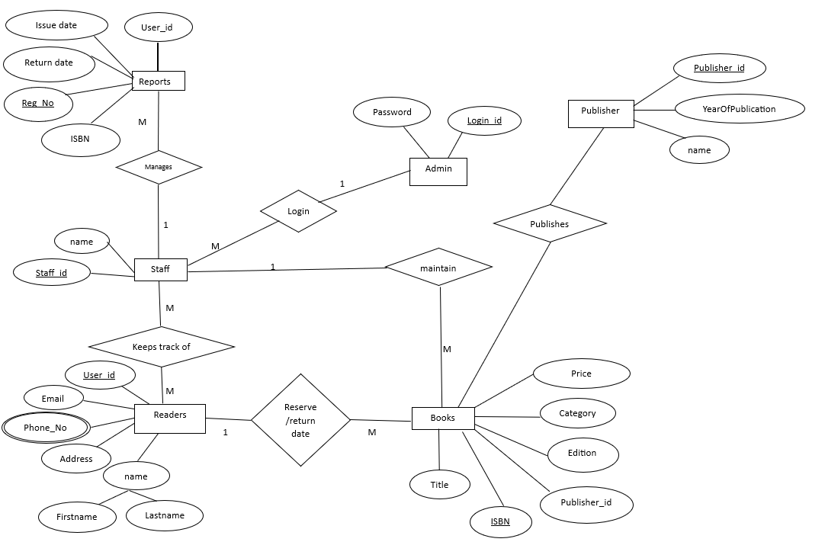

**CONCLUSION:**

In summary, the Library Management System (LMS) is an indispensable tool for modernizing and streamlining the management of library resources and operations. By automating processes such as book cataloging, issuing, returning, and managing user accounts, the system ensures that library activities are efficient, organized, and error-free. It provides a user-friendly platform for both staff and readers, simplifying tasks and enhancing the overall experience.

The key entities—**Admin**, **Staff**, **Books**, **Reports**, **Readers**, and **Publishers**—work together to ensure smooth communication, efficient inventory management, and improved decision-making. With the ability to generate reports, track overdue books, and manage memberships, the LMS allows libraries to maintain control over their resources while offering users easy access to books and other materials.

Moreover, as technology advances, future iterations of LMS can incorporate new features like online catalogs, mobile integration, and AI-driven recommendations, further enhancing the library’s ability to meet the needs of its community. Ultimately, the Library Management System is a vital tool for enhancing the accessibility, organization, and efficiency of library services, supporting both operational goals and user satisfaction.

**DATABASE CREATION QUERY:**

**mysql> CREATE DATABASE LibraryManagement;**

**Query OK, 1 row affected (0.03 sec)**

**mysql> USE LibraryManagement;**

**Database changed**

**mysql> create table Admin(**

**-> LoginID INT PRIMARY KEY,**

**-> Password VARCHAR(255)**

**-> );**

**Query OK, 0 rows affected (0.04 sec)**

**mysql> CREATE TABLE Books (**

**-> ISBN VARCHAR(20) PRIMARY KEY,**

**-> Title VARCHAR(255),**

**-> AuthNo VARCHAR(100),**

**-> Edition VARCHAR(50),**

**-> Category VARCHAR(50),**

**-> Price DECIMAL(10,2),**

**-> Publisher_ID INT,**

**-> FOREIGN KEY (Publisher_ID) REFERENCES Publisher(Publisher_ID) ON DELETE CASCADE**

**-> );**

**Query OK, 0 rows affected (0.05 sec)**

**mysql> CREATE TABLE Staff (**

**-> Staff_ID INT PRIMARY KEY,**

**-> Name VARCHAR(100)**

**-> );**

**Query OK, 0 rows affected (0.03 sec)**

**mysql> CREATE TABLE Publisher (**

**-> Publisher_ID INT PRIMARY KEY,**

**-> Name VARCHAR(100),**

**-> YearOfPublication INT**

**-> );**

**Query OK, 0 rows affected (0.03 sec)**

**mysql> CREATE TABLE Readers (**

**-> User_ID INT PRIMARY KEY,**

**-> Firstname VARCHAR(50),**

**-> Lastname VARCHAR(50),**

**-> Email VARCHAR(100),**

**-> Phone_no VARCHAR(15),**

**-> Address TEXT**

**-> );**

**Query OK, 0 rows affected (0.05 sec)**

**mysql> CREATE TABLE Reports (**

**-> Reg_no INT PRIMARY KEY,**

**-> User_ID INT,**

**-> Book_No VARCHAR(20),**

**-> IssueReturn DATE,**

**-> FOREIGN KEY (User_ID) REFERENCES Readers(User_ID) ON DELETE CASCADE,**

**-> FOREIGN KEY (Book_No) REFERENCES Books(ISBN) ON DELETE CASCADE**

**-> );**

**Query OK, 0 rows affected (0.04 sec)**

**mysql> SHOW TABLES;**

**+-----------------------------+**

**| Tables_in_librarymanagement |**

**+-----------------------------+**

**| admin |**

**| books |**

**| publisher |**

**| readers |**

**| reports |**

**| staff |**

**+-----------------------------+**

**6 rows in set (0.01 sec)**